Compiler Construction Lab
Gull e Zahra (54154)

Lab 4
Task 1
#include <iostream>
using namespace std;

int main() {
string s;
cin >> s;

int state = 0; // q0

for (char c : s) {
if (state == 0) {
if (c == '0') state = 1;
else state = 0;
}
else if (state == 1) {
if (c == '0') state = 1;
else state = 0;
}

}

if (state == 1)
cout << "Accepted";
else
cout << "Rejected";
}

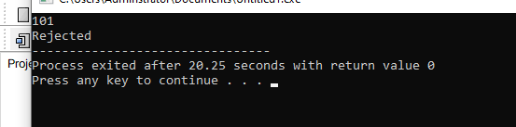
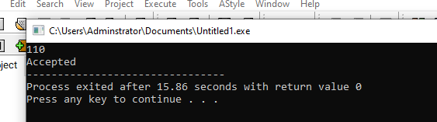

Task 2
#include <iostream>
using namespace std;

int main() {
string s;
cin >> s;

int state = 0; // q0: start

for (char c : s) {
if (state == 0) { // start
if (c == '1') state = 1;
else state = 3; // q_reject
}
else if (state == 1) { // started with 1
if (c == '0') state = 2;
else state = 1;
}
else if (state == 2) { // last read was 0
if (c == '0') state = 2;
else state = 1;
}
else if (state == 3) { // rejected
state = 3;
}
}

if (state == 2)
cout << "Accepted";
else
cout << "Rejected";
}
